**Amblecote Primary School**

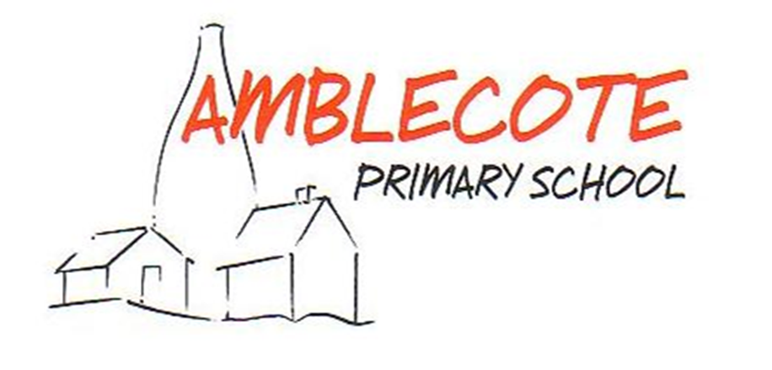

***‘At Amblecote we achieve because in our pupils we believe.’***

**Anti-Bullying Policy**

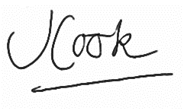

**Responsibility for monitoring this policy: Head teacher and SENDCos**

**Review: annually**

**Updated: November 2021**

**Review date: November 2022**

**Proposed by the Head teacher………………………………………………Mrs J. Cook**

**Approved by Governing Body……………………………………….…… Mrs C. Roberts (Chair of Governors)**

As a result of consultation with all members of the school community, the following definition of bullying has been agreed:

At Amblecote Primary School we believe bullying is “**when someone or a group of people hurt someone else, on purpose, over and over again”.** We agree that bullying isn’t **“single arguments or disagreements, episodes of social rejections or dislike, single episodes or acts of nastiness or spite or random acts of aggression or intimidation”. We use the acronym STOP – Several Times On Purpose**

Bullying can include: name calling; taunting; mocking; making offensive comments; kicking; hitting; taking belongings; producing offensive graffiti; gossiping; excluding people from groups, and spreading hurtful and untruthful rumours.This includes the same inappropriate and harmful behaviours expressed via digital devises (cyber bullying) such as the sending of inappropriate messages by phone, text, Instant Messenger, through web-sites and social networking sites, and sending offensive or degrading images by phone or via the internet.

This policy was written by the Headteacher and PSHE coordinator after a whole-school consultation. It was written in line with the Anti-bullying policy guidance from the Local Authority. It involved all members of the school community, including the PSHE coordinator, governors, parents, pupil, teaching and non-teaching staff and the lunchtime supervisors who were consulted through a series of questionnaires. The questionnaires sought a definition of bullying, personal experience of bullying and the school’s response to these and suggestions for policy content.

The aim of this policy is to promote a school ethos in which bullying is regarded as unacceptable and outlines what Amblecote Primary will do to prevent and tackle bullying.

**Our school community will:**

* Minimise opportunities for bullying through consistent use of our behaviour and anti-bullying policy.
* Discuss, monitor and review our anti-bullying policy on a regular basis.
* Provide continued CPD and training to develop staff awareness and provide a consistent school response to any incidents that may occur.
* Offer workshops for parents and carers to update and inform (to include online-safety awareness).
* Support all staff to promote positive relationships and identify and tackle bullying appropriately.
* Ensure that our children are aware that all bullying concerns will be dealt with sensitively and effectively; that students feel safe to learn; and abide by the anti-bullying policy.
* Report back to parents and carers regarding their concerns on bullying and deal promptly with concerns. Parents and carers in turn work with the school to uphold the anti-bullying policy.
* Seek to learn from good anti-bullying practice elsewhere and utilise support from the Local Authority and other relevant organisations when appropriate.

**Forms of bullying covered by this Policy**

Bullying can happen to anyone. This policy covers all types of bullying, whether face to face or in cyberspace, including:

* Bullying related to race, religion or culture.
* Bullying related to LDD (learning difficulties or disability).
* Bullying related to appearance or health conditions.
* Bullying related to sexual orientation (homophobic bullying).
* Bullying of young carers or looked after children or otherwise related to home circumstances.
* Sexist, sexual and transphobic (Intense dislike of or prejudice against transsexual or transgender people) bullying.
* Peer on Peer bullying and abuse

**Preventing, identifying and responding to bullying**

The school community will:

* Appoint a named anti-bullying co-ordinator: **Mrs Marie Pickett**.
* Work with staff and outside agencies to identify all forms of bullying.
* Actively provide systematic opportunities to develop children’s’ social and emotional skills, including their resilience (weekly PSHE/RSE lessons).
* Consider all opportunities for addressing bullying including through the curriculum, displays, assemblies, peer support and through the School Council.
* Train all staff including lunchtime staff, learning mentors and support staff to identify bullying and follow school policy and procedures, including recording incidents.
* Actively create “safe spaces” for vulnerable children.
* Record incidents of bullying in whole school file: CPOMs.
* Create a wishes and worries boxes and friendship benches.
* Nominate and train friendship ambassadors for each class at the start of each new academic year.
* Use a variety of interventions to resolve the issues between those who bully and those who have been bullied.

**Involvement of children**

We will:

* Regularly seek children’s’ views on the extent and nature of bullying (School Council and Friendship Ambassadors).
* Ensure children know how to express worries and anxieties about bullying (adult, peer support or wishes and worries box).
* Ensure all children are aware of the range of sanctions which may be applied against those engaging in bullying.
* Involve children in anti-bullying campaigns in schools, regular assemblies and themed lessons.
* Publicise the details of help-lines and websites.
* Offer support to students who have been bullied and to those who are bullying in order to address the problems they have.

**Liaison with parents and carers**

We will:

* Ensure that all parents and carers know who to contact if they are worried about bullying.
* Ensure all parents and carers know about our complaints procedure and how to use it effectively.
* Ensure all parents and carers know where to access independent advice about bullying.
* Work with all parents, carers and the local community to address issues beyond the school gates that lead to bullying.

**Links with other school policies and practices**

This Policy links with a number of other school policies, practices and action plans including:

* Behaviour policy
* Complaints policy
* E-Safety policy
* Cyber Bullying policy
* Safeguarding procedures
* Acceptable use policy
* Citizenship and PSHE/RSE curriculum
* Action plans relating to pupil well-being and community cohesion
* Recording of racial incidents

**Responsibilities**

It is the responsibility of:

* School Governors to take a lead role in monitoring and reviewing this policy.
* Governors, the Headteacher, Senior Managers, Teaching and Non Teaching staff to be aware of this policy and implement it accordingly.
* The Headteacher to communicate the policy to the school community.
* Students to abide by the policy.

The named Governor with lead responsibility for this policy is: **Claire Roberts**

The named member of staff with lead responsibility for this policy is: **Marie Pickett**

This policy will be monitored and reviewed: **November 2022**

The named Governor for bullying will report on a regular basis to the governing body on incidents of bullying and outcomes. Any issues identified through the monitoring of this policy will be incorporated into the school’s action planning. The school uses guidance by the DfEand Dudley Children’s Services to inform its action planning.

*Further information and guidance can be found at:*

<http://www.anti-bullyingalliance.org.uk/resources/aba-resources.aspx>